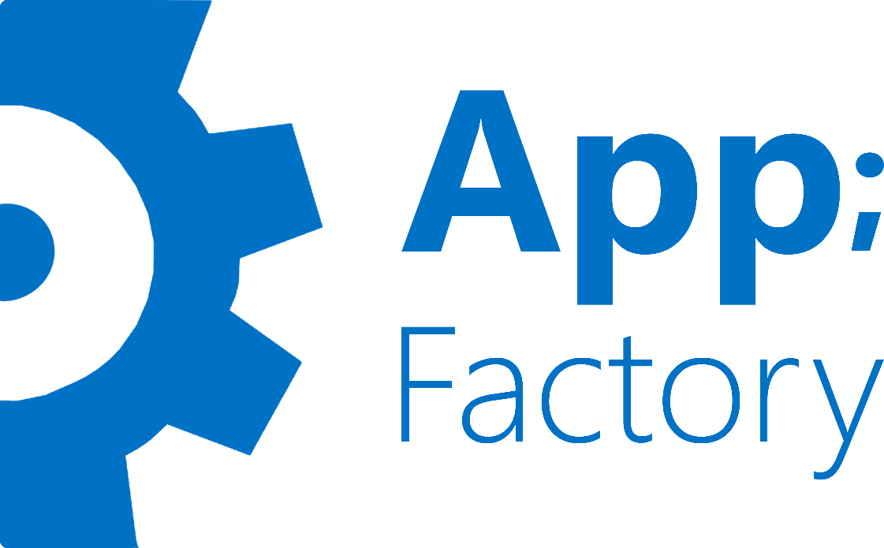

Appfactory Team One

Delivered To : Mr/ Mohamed Ghoneim

From : Amira Mahmoud

Additional Tasks Report

Task One: Rejected Applicant can apply again in the same cycle

1. DB Changes: I had to change table (Application_Applicant) which has a composite key of (ApplicationID and ApplicantID) so that the user can apply in the same application more than once, first I made a new key from (ApplicantID , SubmissionDate) but I changed date because when I try to select that row from database using SubmissionDate it gives an error cause it’s very hard to compare two dates .

So I created new coloumn Called ID and made it the new PK then the problem is solved.

1. Filters : I had to change the ApplyFilter so it can allow the applicant to apply again in the same cycle as long as he/she is rejected and also if the user didn’t complete submission it will redirect him to the step he stopped at(This part wasn’t handled in the filter before it was handled only in the dashboard in user profile).
2. Applicant Controller : The actions in ApplicantController only used to add new record but not updating it , so I added this part in the post methods (They are 5 methods) , so the user can edit his application when applying again.
3. The previous button’s problem : I changd the link from window.back to redirectToAction , this solution works fine with all steps except the first one due to the ApplyFilter.
4. The Problem with the first previous button was solved by checking the route values.

Task Two: The admin can change the role from admin to user

1. Change role action : if the user is Admin change his role back to user again.
2. UsersList action : it was only used to list users , now it views both admins and users.
3. Views : first I created a list that displays only admins but I was told it wasn’t the right requirements so I made the Users List display both admins and users.

Task Three: Upload Profile

1. The ApplicantDetails takes data from 5 tables so to add the form that uploads the user’s resume if it doesn’t exist I had to use partial view called Upload CV.
2. UserController : I added action called UploadCV.

Task Four: Message Reply

1. I added A partial view called Reply and added it to UserMessages View.
2. I used modal for Reply to messages.
3. I handled UI errors that appear when modal pops up(when modal pops up , the header and footer cover it).

Task Five: Intern Locations